Corporate Social Responsibility Policy

Purpose

Fallow Management Ltd recognises that we have a responsibility to our customers, staff, the environment and the community in which we work to ensure that we act responsibly at all times.

Policy
In all our operations we promote an open and honest approach, we work hard to adopt best practice, we encourage feedback from all our partnerships, we promote a positive company image in local communities and we actively aim to consistently improve the services we provide especially within the environment by: -

- Providing full transparency with customers regarding costs and service provided, everything is available for the customer to review at anytime
- Ensuring full transparency with staff regarding service provided and support available on site
- Meeting and where possible exceeding all relevant legal requirements
- Striving to achieve nationally recognised memberships
- Adhering to the environment management system as outlined in ISO 14001
- Continually requesting and responding to feedback provided by customers and staff
- Pursuing initiatives for the reduction and recycling of waste, as well as the efficient use of energy and passing this information forward to customers
- Encouraging staff to get involved in local projects through sponsorship and paid time off

Implementation
It is the responsibility of the Board to ensure that we adhere to the targets set by communicating our objectives throughout the company and providing adequate resources and support to achieve our goals. Every employee of Fallow Management Ltd has a responsibility to ensure good service to the customer, honesty and integrity to colleagues, reduced impact on the environment and a commitment to the local community.
Fallow Management Ltd believes that by embedding the ethos of this policy at all levels and through positive leadership our objectives can be achieved.
Signed: 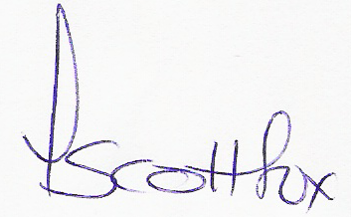 Date: June 2021

Name: Tracey Scott-Fox Title: Managing Director

