QUALITY POLICY

The continuing policy of Fallow Management Ltd is to provide a professional and efficient service to meet all of the requirements of our customers. This achievement will result in securing efficiency and enhancement of long-term profitability.

The Management Team bears the responsibility for establishing, maintaining and implementing the system for controlling those particular activities for which they are responsible. We undertake to ensure through instruction, practical example and training that quality is the aim of all members of the Organisation and that each employee has a proper understanding of the importance of the quality system function and its direct relevance to the success of the Organisation.

Equally every employee is responsible for, and will be trained to perform the duties required by his or her specific role. Furthermore, the Organisation will ensure that any sub-contractors employed for a particular function will meet specified requirements and will accept the responsibility for their work.

The organisation has a policy of continual improvement and setting of quality objectives in line with the framework laid down within ISO 9001:2015 Standard.

We hereby certify that this Quality Manual and the Standard Operating Procedures Manual accurately describes the Quality System in use within the Organisation to meet the requirements of ISO 9001:2015.

The Quality System will be monitored regularly under the Top Management’s ultimate responsibility with regular reporting of the status and effectiveness at all levels.

Signed: 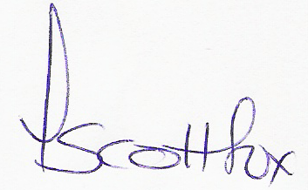

Date: June 2021

